**Understanding OOP Concepts through Zoo Animal Management**

In this lecture, we'll explore how to identify classes and behaviors in a programming problem statement while learning essential Object-Oriented Programming (OOP) concepts. Our problem statement involves creating a program to manage animals in a zoo.

Let's break down the problem statement:

**Problem Statement:**"You've been hired by a zoo to help manage their animals more efficiently. Your task is to create a program that models these animals and their behaviors. Each animal should have its own class, and they should be able to perform unique actions, like making sounds and doing tricks. Your goal is to identify the classes and functions needed to build this animal management system for the zoo."

Now, let's analyze this statement and apply OOP concepts:

Drawbacks of not using proper OOP:

**Task 1:** Modify the age of a lion and describe the challenges in maintaining data consistency without encapsulation.

**Task 2:** Add a new animal (e.g., a zebra) and add its attributes and behaviors.

**Task 3:** Create a function to describe an animal, and then use that function to describe multiple animals.

**Task 4:** Add three more animals

**Explanations:**

**1) Lack of Data Encapsulation:**In the non-OOP code, data for animals is stored in separate variables (lionName, lionAge, elephantName, elephantAge). This approach lacks data encapsulation, which means that data (attributes) and the methods (behaviors) that operate on that data are not encapsulated within a single unit (class).

**2) Code Duplication:**Attributes and behaviors for each animal are mixed together in the Main method, leading to code duplication when describing multiple animals. This means writing the same code for different animals, which violates the DRY (Don't Repeat Yourself) principle.

**3) Lack of Code Reusability:**The non-OOP code doesn't promote code reusability. If you want to add more animals or use the same animal descriptions elsewhere in the program, you would need to manually replicate the code. There's no way to encapsulate the animal's description as a reusable unit.

**4) Lack of Organization and Scalability:**The non-OOP code quickly becomes disorganized and less scalable as you add more animals. It's challenging to maintain and understand because attributes and behaviors are scattered throughout the Main method. As the program grows, it becomes harder to manage.

**Solutions:**

**1. Lack of Data Encapsulation:**

In OOP, data and methods are encapsulated within classes. We create a class to represent each animal, encapsulating its attributes (data) and behaviors (methods) within that class.

**Example:**

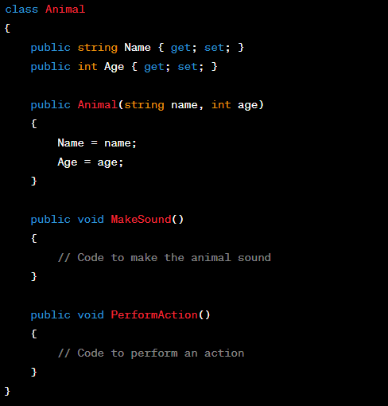

**2. Code Duplication:**

With OOP, we can create instances of the Animal class for each animal, eliminating code duplication. We reuse the same class definition to create multiple animal objects.

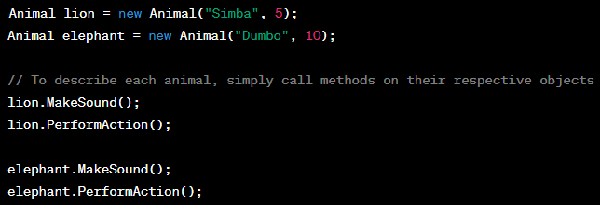

**3. Code Reusability:**

In OOP, the Animal class can be reused to describe any animal. If you want to add more animals or use the same animal description elsewhere, you can create new instances of the Animal class.

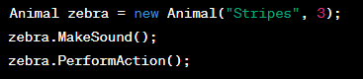

**4. Organization and Scalability:**

OOP promotes organization and scalability. Each class represents a distinct entity (in this case, an animal) with its attributes and behaviors. As you add more animals or features, the code remains organized and manageable.

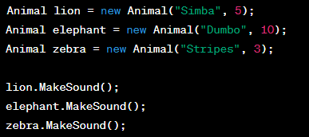

Let’s work on the problem statement:

**1. Classes:**Classes are like blueprints for objects. In this problem statement, we need to identify the different types of animals that will be part of our system. Each type of animal should have its own class.

**Example Classes:**

* Lion
* Elephant
* Giraffe
* Penguin
* Monkey

Each of these classes will represent a specific type of animal in the zoo.

**2. Objects:**Objects are instances of classes. In our case, objects represent individual animals. We'll create objects from these classes to represent each animal in the zoo.

**Object Instances:**

* Simba (an instance of the Lion class)
* Dumbo (an instance of the Elephant class)
* Gigi (an instance of the Giraffe class)
* Penny (an instance of the Penguin class)
* Max (an instance of the Monkey class)

**3. Behaviors (Methods):**Behaviors are actions that objects can perform. In the problem statement, we're told that animals should be able to perform unique actions, like making sounds and doing tricks. These actions are implemented as methods within our classes.

**Example Behaviors (Methods):**

* **MakeSound():** Each animal class should have a method to make its unique sound (e.g., Lion roars, Penguin squawks).
* **DoTrick():** Animals may have different tricks they can perform (e.g., Monkey swings, Elephant sprays water).

**4. Encapsulation:**Encapsulation is the concept of bundling data (attributes) and methods (behaviors) that operate on that data into a single unit (class). In our classes, we'll encapsulate the animal's attributes (e.g., name, age) and behaviors (e.g., MakeSound() and DoTrick() methods) together.

**5. Inheritance:**Inheritance allows a class (subclass or child class) to inherit the attributes and behaviors of another class (parent class or superclass). In our zoo management system, we might have common attributes or behaviors shared among certain animals. For example, all animals might have a name and age. In such cases, we can create a base class (e.g., Animal) and have other animal classes inherit from it.

**6. Polymorphism:**Polymorphism allows objects of different classes to be treated as objects of a common superclass. It enables us to write code that can work with objects of various classes in a consistent way. For instance, we can have a method that accepts an Animal object and call MakeSound() on it, and it will work for any animal object.

In conclusion, by identifying classes, objects, behaviors, and applying OOP concepts such as encapsulation, inheritance, and polymorphism, we can design an efficient animal management system for the zoo. This practical example illustrates how OOP principles can be applied to solve real-world problems and create modular, maintainable, and flexible software.

We have a base class **Animal** that includes common attributes like Name and Age, along with virtual methods **MakeSound()** and **DoTrick()** that provide default behavior for all animals.

We create two derived classes, **Lion** and **Elephant**, that inherit from the Animal class. These classes override the **MakeSound()** and **DoTrick()** methods to provide specific behaviors for lions and elephants.

In the Main method, we create instances of Lion and Elephant and call their methods to make sounds and perform tricks.

This code demonstrates how OOP concepts like inheritance and polymorphism allow us to create a flexible and maintainable animal management system for our zoo. You can extend this code to include more animal types and behaviors as needed.

